

Darrington CE Primary School
Writing Long Term Plan

Sycamore
Year 3 and 4 – Cycle 1
Autumn 1 | Autumn 2 | Spring 1 | Spring 2 | Summer 1 | Summer 2
Home Sweet Home (Video)   | The Firework Maker’s Daughter   | For the Birds (Video)  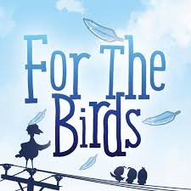 | Marshmallows (Video)   | The Miraculous Journey of Edward Tulane  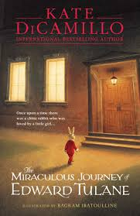 | Tabula Rasa (Video)  
Adventure | Story | Fable (Story with a moral) | Suspense Story | Fantasy Story | Sci-Fi Story
Revisit the sentence types taught in Year 2.  Prior Learning: Children will already have learnt in Year 2 subordination using ‘when’, ‘if’, ‘that’ and ‘because’.  Y3 - Express time, place and cause using subordinating conjunctions ‘when’, ‘before’, ‘after’, ‘while’ and ‘so’.  Y3 - Use inverted commas to punctuate direct speech.  “Let’s go home now!” called the owner.  The owner called, “Let’s go home now!”  Y4 – Use inverted commas and other punctuation to indicate direct speech.  “Let’s go home now!” the owner called, “It’s time for dinner!”  Verb, person sentence  Running, Sarah almost tripped over her own feet. | Prior Learning: Children will already have learned how to use full stops, question marks and exclamation marks to demarcate sentences.  Y3 - Express time, place and cause using prepositions.  Y4 – Use pronouns within and across sentences: 1st person  Y3 - Use inverted commas to punctuate direct speech.  “Let’s go home now!” called the owner.  The owner called, “Let’s go home now!”  Y4 – Use inverted commas and other punctuation to indicate direct speech.  “Let’s go home now!” the owner called, “It’s time for dinner!”  2 pairs sentence  Exhausted and worried, cold and hungry, they did not know how much further they had to go. | Y3 - Write sentences using the conjunction ‘although’.  Y3 - Use inverted commas to punctuate direct speech.  “Let’s go home now!” called the owner.  The owner called, “Let’s go home now!”  Y4 – Use inverted commas and other punctuation to indicate direct speech.  “Let’s go home now!” the owner called, “It’s time for dinner!”  3_ed sentence  Confused, shocked, scared, the children ran from the burning building. | Y3 - Express time, place and cause using subordinating conjunctions ‘when’, ‘before’, ‘after’, ‘while’ and ‘so’.  Y3 - Use inverted commas to punctuate direct speech.  “Let’s go home now!” called the owner.  The owner called, “Let’s go home now!”  Y4 – Use inverted commas and other punctuation to indicate direct speech.  “Let’s go home now!” the owner called, “It’s time for dinner!”  Personification of weather sentence  The wind stroked the space shuttle gently before lifting off. | Y3 - Express time, place and cause using prepositions.  Y3 - Use inverted commas to punctuate direct speech.  “Let’s go home now!” called the owner.  The owner called, “Let’s go home now!”  Y4 – Use inverted commas and other punctuation to indicate direct speech.  “Let’s go home now!” the owner called, “It’s time for dinner!”  Simile sentence  The huge green monster chased after the children like a tornado. | Y3 - Use inverted commas to punctuate direct speech.  “Let’s go home now!” called the owner.  The owner called, “Let’s go home now!”  Y4 – Use inverted commas and other punctuation to indicate direct speech.  “Let’s go home now!” the owner called, “It’s time for dinner!”  Last word, first word sentence  Brilliant, the whole day was just brilliant!
Tuesday  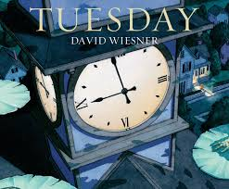 | Girl and Robot (Video)   | Krindlekrax  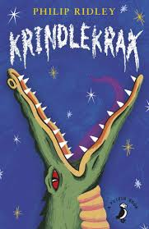 | Arthur and the Golden Rope   | Spy Fox (Video)   | The Tunnel  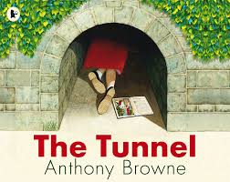
Newspaper Report | Instructions | Non-chronological report | Diary | Persuasive | Balanced Argument
Y3 - Use inverted commas to punctuate direct speech.  Y4 – Use inverted commas and other punctuation to indicate direct speech. | Y3 - Express time, place and cause using adverbs.  Y4 – Write sentences using fronted adverbials.  Double -ly sentence  She sang soulfully and emotionally. | Y3 - Use the present perfect form of verbs to indicate a completed action.  Y4 – Use pronouns within and across sentences: 2nd person | Y3 - Write sentences using the conjunction ‘although’. | Y3 - Express time, place and cause using adverbs.  Y4 – Write sentences using fronted adverbials.  Emotion word, comma sentence  Desperate, she screamed for help. | Y3 - Use the present perfect form of verbs to indicate a completed action.
Poetry |  | Poetry |  | Poetry
‘The Witches Spell’ by William Shakespeare |  | ‘Slowly’ by James Reeves |  | ‘The River’ by Valerie Bloom
Performance Poetry |  | Repetitive Adverbs Poem |  | Metaphor Poem

Year 3 and 4 – Cycle 2
Autumn 1 | Autumn 2 | Spring 1 | Spring 2 | Summer 1 | Summer 2
The Little Shoemaker (Video)   | My Name is Not Refugee   | A Midsummer Night’s Dream  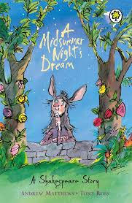 | Flotsam  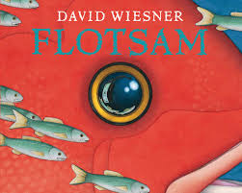 | Free Lance and the Lake of Skulls  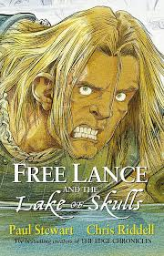 | Who Let the Gods Out?  
Traditional Tale | First Person Story | Retelling | Retelling | Adventure | Myth
Revisit the sentence types taught in Year 2.  Prior Learning: Children will already have learnt in Year 2 subordination using ‘when’, ‘if’, ‘that’ and ‘because’.  Y3 - Express time, place and cause using subordinating conjunctions ‘when’, ‘before’, ‘after’, ‘while’ and ‘so’.  When the dog was ready, he waited by the door for his owner.  Y3 - Use inverted commas to punctuate direct speech.  “Let’s go home now!” called the owner.  The owner called, “Let’s go home now!”  Y4 – Use inverted commas and other punctuation to indicate direct speech.  “Let’s go home now!” the owner called, “It’s time for dinner!”  Verb, person sentence  Running, Sarah almost tripped over her own feet. | Prior Learning: Children will already have learned how to use full stops, question marks and exclamation marks to demarcate sentences.  Y3 - Express time, place and cause using prepositions.  Across the park, the dog could see others playing.  Behind him, his owner watched cautiously.  The dog park was at the end of a long road.  Y4 – Use pronouns within and across sentences: 1st person  I once visited the popular park.  Y3 - Use inverted commas to punctuate direct speech.  “Let’s go home now!” called the owner.  The owner called, “Let’s go home now!”  Y4 – Use inverted commas and other punctuation to indicate direct speech.  “Let’s go home now!” the owner called, “It’s time for dinner!”  2 pairs sentence  Exhausted and worried, cold and hungry, they did not know how much further they had to go. | Y3 - Use inverted commas to punctuate direct speech.  “Let’s go home now!” called the owner.  The owner called, “Let’s go home now!”  Y4 – Use inverted commas and other punctuation to indicate direct speech.  “Let’s go home now!” the owner called, “It’s time for dinner!”  3_ed sentence  Confused, shocked, scared, the children ran from the burning building. | Y3 - Express time, place and cause using subordinating conjunctions ‘when’, ‘before’, ‘after’, ‘while’ and ‘so’.  Y3 - Use inverted commas to punctuate direct speech.  “Let’s go home now!” called the owner.  The owner called, “Let’s go home now!”  Y4 – Use inverted commas and other punctuation to indicate direct speech.  “Let’s go home now!” the owner called, “It’s time for dinner!”  Personification of weather sentence  The wind stroked the space shuttle gently before lifting off. | Y3 - Express time, place and cause using prepositions.  Y3 - Use inverted commas to punctuate direct speech.  “Let’s go home now!” called the owner.  The owner called, “Let’s go home now!”  Y4 – Use inverted commas and other punctuation to indicate direct speech.  “Let’s go home now!” the owner called, “It’s time for dinner!”  Simile sentence  The huge green monster chased after the children like a tornado. | Y3 - Use inverted commas to punctuate direct speech.  “Let’s go home now!” called the owner.  The owner called, “Let’s go home now!”  Y4 – Use inverted commas and other punctuation to indicate direct speech.  “Let’s go home now!” the owner called, “It’s time for dinner!”  Last word, first word sentence  Brilliant, the whole day was just brilliant!
Rumblestar   | Evol (Video)   | Once in a Lifetime (Video)   | The Shirt Machine (Video)   | Reverso (Video)  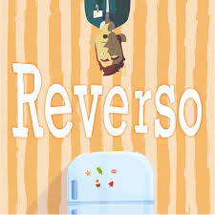 | The Present (Video)  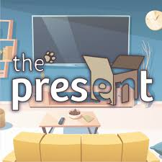
Non-chronological report | Letter | Persuasive | Explanation | Newspaper Report | Diary
Prior Learning: Children will have already learned to use conjunctions ‘and’, ‘but’ and ‘so’ in Year 2.  Y3 - Write sentences using the conjunction ‘although’.  Although the dog was alone, he was not worried. | Prior Learning: Children will have already learned how to use adverbs of time – ‘first’, ‘next’ and ‘finally’.  Y3 - Express time, place and cause using adverbs.  Meanwhile, the birds in the trees watched as their park was overrun.  Soon, the dogs would go back home.  Y4 – Write sentences using fronted adverbials.  Slowly, the cat made his way towards his prey.  After a few hours, the park was empty.  Double -ly sentence  She sang soulfully and emotionally. | Y3 - Use the present perfect form of verbs to indicate a completed action.  The dogs and cats living near the park have become friends.  Y4 – Use pronouns within and across sentences: 2nd person  You wouldn’t believe how many dogs visit the park every day. | Y3 - Write sentences using the conjunction ‘although’. | Y3 - Express time, place and cause using adverbs.  Y4 – Write sentences using fronted adverbials.  Y3 - Use inverted commas to punctuate direct speech.  “Let’s go home now!” called the owner.  The owner called, “Let’s go home now!”  Y4 – Use inverted commas and other punctuation to indicate direct speech.  “Let’s go home now!” the owner called, “It’s time for dinner!”  Emotion word, comma sentence  Desperate, she screamed for help. | Y3 - Use the present perfect form of verbs to indicate a completed action.
Poetry |  | Poetry |  | Poetry
‘The Door’ by Miroslav Holub |  |  |  | ‘Double Trouble’ by Jackie Kay
Free Verse Poetry |  | Kennings Poem |  | Anotnyms Poem

