

Darrington CE Primary School
Writing Long Term Plan

Oak
Year 5 and 6 – Cycle 1
Autumn 1 | Autumn 2 | Spring 1 | Spring 2 | Summer 1 | Summer 2
Red Miss Take (Video)   | Eye of the Storm (Video)   | Tale of the Three Brothers (Video)  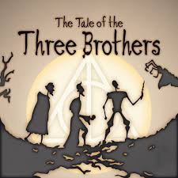 | Francis (Video)   | The Lost Thing  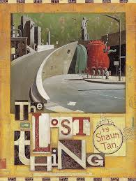 | The Arrival  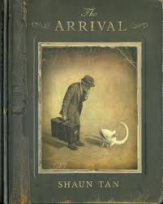
Traditional Tale | Sci-Fi Story | Diary | Suspense Story | Short Burst Writing | Securing end of year objectives
Prior Learning: Children will have already learned about clauses and subordination.  They already have knowledge of using inverted commas.  Y5 - Write sentences using relative clauses with relative pronouns – who, where, which, whose, that.  The dog could smell the hotdogs, which were being cooked nearby.  The park, which had a large gate at the front, was a regular stop for many dog walkers.  Y5 – Write sentences with the relative pronouns omitted.  Nothing that the dog did would convince the human to share his food.  The more, the more sentence  The more angry he became, the more he hammered his fist on the table. | Y5 – Write sentences using an -ed clause (past participle).  Horrified to see the cat playing with his favourite toy, the dog began plotting his revenge.  Y6 – Use semi-colons to mark boundaries between independent clauses.  The dog was exhausted; he had been charging happily around the park all day.  Adjective, same adjective sentence  He was a fast runner, fast because he needed to be. | Y5 – Write sentences using an -ing clause (present participle)  Spotting his owner at the edge of the park, the dog grabbed his toy and ran to greet him.  Y5 – Link ideas across paragraphs using adverbials for time, place or number.  Later that day, the dog returned home.  Additionally, there is a lake in the park.  ___ing, ___ed sentence  Dancing in the studio, she watched in the mirror as a ghost appeared. | Y5 – Use similes to start sentences.  With cheeks red as tomatoes, the owner chased his cheeky dog.  Y5 – Use adverbs to indicate degrees of possibility. E.g. maybe, perhaps, certainly, definitely, possibly, clearly, obviously, probably.  Perhaps the dog should have stayed curled up in bed that fateful day at the park.  Outside (Inside) sentence  Kate ate the cake that was given to her with enthusiasm and delight. (Inside, however, she wished she had turned down the offer.) | Revision and application of all sentence types within short burst writing.
Room 13   | Macbeth  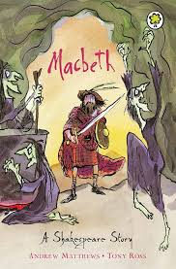 | Holes  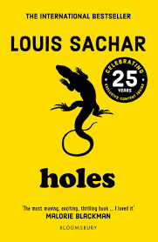 | Stitch Head  
Persuasive | Balanced Argument | Non-Chronological Report | Newspaper Report
Prior Learning: Children will have already learned how to use commas to separate clauses and adverbials for time and place.  Y5 – Use commas to avoid ambiguity.  The man walked with his dog treats overflowing from his pockets.  The man walked with his dog, treats overflowing from his pockets.  Y6 – Use colons to introduce a list and use semi-colons within lists when required.  The dog only brought the essentials on his walk: a large bag of treats to share with friends; seven tennis balls in case any went missing; and his super smelling sense.  3 bad – dash question sentence  Cold, dark, airlessness – which would kill the spaceman first? | Y5 – Link ideas across paragraphs using adverbials for time, place or number.  Later that day, the dog returned home.  Additionally, there is a lake in the park.  Y5 – Use modal verbs to indicate degrees of possibility. E.g. can/could, will/would, shall/should, may/might, must/ought.  The dog might have saved his toy from the lake if it wasn’t for the sneaky duck.  Some; others sentence  Some people love football; others just can’t stand it. | Y5 – Indicate parenthesis by using brackets, dashes or commas.  Dogs, I believe, are my favourite animal.  Labradors (a breed of dog) are my favourite animal.  Labradors – a breed of dog that varies in colour – are my favourite animal.  Y6 – Use active and passive voice in order to alter sentence order.  Active – The cat stole the treats.  Passive – The treats were stolen by the cat.  OR – The treats were stolen.  P.C sentence (both/and, not so/as, neither/nor, as/as)  It was both cold and unpleasant for him to work there. | Y5 – Use the perfect form of verbs to mark the relationship of time and cause using the past perfect (had) and the present perfect (have/has).  The dog had tried everything he could to find his lost toy.  ‘I have tried everything.’ thought the dog.  Y6 – Use the subjunctive form for formal speech and writing.  If the dog were to reach the park in time, he would need to hurry.  One word, one phrase definition  Monday: the longest day of the week.
Poetry |  | Poetry
‘The Poem Imagines It Is A Horror Film’ by Pie Corbett |  | ‘If You Were a Carrot’ by Berlie Doherty
Idiom Poetry |  | Subjunctive Form Poem

Year 5 and 6 – Cycle 2
Autumn 1 | Autumn 2 | Spring 1 | Spring 2 | Summer 1 | Summer 2
The Nowhere Emporium  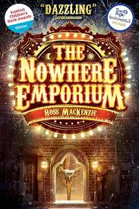 | Clockwork  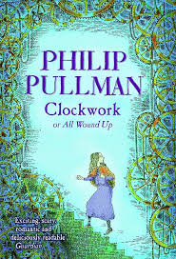 | The Piano (Video)   | The Barnabus Project  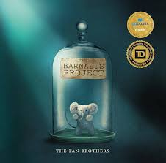 | Rose Blanche  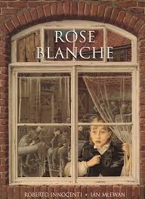 | The Island  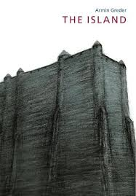
Fantasy Story | Ghost Story | Flashback Story | Adventure Story | Short Burst Writing | Securing end of year objectives
Y5 - Write sentences using relative clauses with relative pronouns – who, where, which, whose, that.  The dog could smell the hotdogs, which were being cooked nearby.  The park, which had a large gate at the front, was a regular stop for many dog walkers.  Y5 – Write sentences with the relative pronouns omitted.  Nothing that the dog did would convince the human to share his food.  The more, the more sentence  The more angry he became, the more he hammered his fist on the table. | Y5 – Write sentences using an -ed clause (past participle).  Horrified to see the cat playing with his favourite toy, the dog began plotting his revenge.  Y6 – Use semi-colons to mark boundaries between independent clauses.  The dog was exhausted; he had been charging happily around the park all day.  Adjective, same adjective sentence  He was a fast runner, fast because he needed to be. | Y5 – Write sentences using an -ing clause (present participle)  Spotting his owner at the edge of the park, the dog grabbed his toy and ran to greet him.  Y5 – Link ideas across paragraphs using adverbials for time, place or number.  Later that day, the dog returned home.  Additionally, there is a lake in the park.  ___ing, ___ed sentence  Dancing in the studio, she watched in the mirror as a ghost appeared. | Y5 – Use similes to start sentences.  With cheeks red as tomatoes, the owner chased his cheeky dog.  Y5 – Use adverbs to indicate degrees of possibility. E.g. maybe, perhaps, certainly, definitely, possibly, clearly, obviously, probably.  Perhaps the dog should have stayed curled up in bed that fateful day at the park.  Outside (Inside) sentence  Kate ate the cake that was given to her with enthusiasm and delight. (Inside, however, she wished she had turned down the offer.) | Revision and application of all sentence types within short burst writing.
Pandora (Video)   | The Lighthouse (Video)   | The Tempest  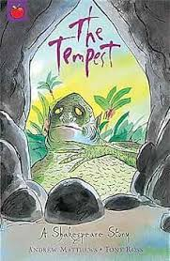 | Survivors  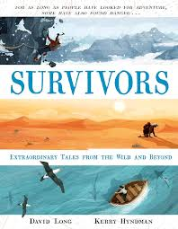
Non-Chronological Report | Newspaper Report | Balanced Argument | Biography
Y5 – Use commas to avoid ambiguity.  The man walked with his dog treats overflowing from his pockets.  The man walked with his dog, treats overflowing from his pockets.  Y6 – Use colons to introduce a list and use semi-colons within lists when required.  The dog only brought the essentials on his walk: a large bag of treats to share with friends; seven tennis balls in case any went missing; and his super smelling sense.  3 bad – dash question sentence  Cold, dark, airlessness – which would kill the spaceman first? | Y5 – Link ideas across paragraphs using adverbials for time, place or number.  Later that day, the dog returned home.  Additionally, there is a lake in the park.  Y5 – Use modal verbs to indicate degrees of possibility. E.g. can/could, will/would, shall/should, may/might, must/ought.  The dog might have saved his toy from the lake if it wasn’t for the sneaky duck.  P.C sentence (both/and, not so/as, neither/nor, as/as)  It was both cold and unpleasant for him to work there. | Y5 – Indicate parenthesis by using brackets, dashes or commas.  Dogs, I believe, are my favourite animal.  Labradors (a breed of dog) are my favourite animal.  Labradors – a breed of dog that varies in colour – are my favourite animal.  Y6 – Use active and passive voice in order to alter sentence order.  Active – The cat stole the treats.  Passive – The treats were stolen by the cat.  OR – The treats were stolen.  Some; others sentence  Some people love football; others just can’t stand it. | Y5 – Use the perfect form of verbs to mark the relationship of time and cause using the past perfect (had) and the present perfect (have/has).  The dog had tried everything he could to find his lost toy.  ‘I have tried everything.’ thought the dog.  Y6 – Use the subjunctive form for formal speech and writing.  If the dog were to reach the park in time, he would need to hurry.  One word, one phrase definition  Monday: the longest day of the week.
Poetry |  | Poetry
‘The Greengrocer’ |  | ‘The Magic Box’ by Kit Wright
Personification Poem |  | Exaggeration Poem

