

Darrington CE Primary School
Writing Long Term Plan

Willows
Year 1 – Read Write Inc.
Autumn 1 | Autumn 2 | Spring 1 | Spring 2 | Summer 1 | Summer 2
Children are taught to write using their Set 2 sounds  ay, ee, igh, ow, oo, oo, ar, or, air, ir, ou, oy  Children are taught to write words using their Set 2 sounds.  Children write some common exception words.  Children write dictated simple sentences with clear finger spaces. E.g. Jack was a poor boy.  Children can write a simple sentence independently that is able to be read by an adult. They use phonetically plausible spellings. | Children write further common exception words.  Children write dictated simple sentences with clear finger spaces and full stops. E.g. Snow White was tricked by the wicked queen.  Children are taught to write their Set 3 sounds.  ea, oi, a-e, i-e, o-e, u-e, aw, are, ur  Children can write a simple sentence independently that is able to be read by an adult. They use phonetically plausible spellings. | er, ow, ai, oa, ew, ire, ear, ure  Children are taught to write words using the Set 3 sounds.  Children write further common exception words.  Children write dictated simple sentences and some compound sentences with clear finger spaces and full stops. E.g. The Little Red Hen knew that the sky was falling and he went to tell the king.  Children write multisyllabic words with support.  Children can write a simple sentence independently that is able to be read by an adult. They use phonetically plausible spellings. | tious, tion, cious  Children are taught to write further Set 3 sounds.  Children are taught to write words using further Set 3 sounds.  Children write further common exception words.  Children write dictated simple sentences and some compound sentences with clear finger spaces and full stops. E.g. The big bad mouse fooled the Gruffalo and made him angry.  Children write multisyllabic words with increasing independence.  Children can write a simple sentence independently that is able to be read by an adult. They use phonetically plausible spellings. | Children are taught to write words using further Set 3 sounds.  Children write further common exception words.  Children write dictated simple sentences and some compound sentences with clear finger spaces and full stops. E.g.  Children write multisyllabic words, including words with suffix endings.  Children can write simple sentences and compound sentences independently that are able to be read by an adult. They use phonetically plausible spellings. | Children are taught to write words using Set 3 sounds.  Children independently write a number of simple and compound sentences that retell a familiar story or event with clear finger spaces, full stops and capital letters.  Children write multisyllabic words within sentences, including words with suffix endings and the prefix -un.  Children can write simple sentences and compound sentences independently that are able to be read by an adult. They use phonetically plausible spellings.

Year 2 – Read Write Inc.
Autumn Term
Children in Team Dolphin continue to follow the Read Write Inc. scheme of learning.

Children will:
- Write words using the Set 3 sounds.
- Begin to make accurate spelling choices.
- Recap all Year 1 common exception words.
- Begin to learn to spell some Year 2 common exception words.
- Write dictated sentences with clear finger spaces, capital letters and full stops.
- Write multisyllabic words with more independence.
- Write words with suffix endings taught in Year 1 (ed, ing, er, est, es/s).

Year 1 and 2 – Cycle 1
Autumn 1 | Autumn 2 | Spring 1 | Spring 2 | Summer 1 | Summer 2
Dogs Don’t Do Ballet  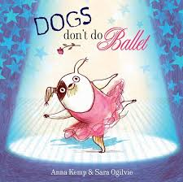 | The Squirrels Who Squabbled  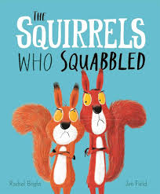 | The Storm Whale  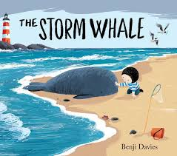 | The Black Hat (Video)   | Zahra (Video)   | The Dark  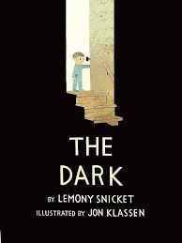
Retelling | Retelling | Retelling | Retelling | Retelling | Retelling
Y1 - Capital Letters and Full Stops  The dog went to the park.  Y2 - Use the conjunction ‘or’ to link words.  The dog can choose a ball or a treat. | Y1 - Use question marks to demarcate sentences.  Why did the dog go to the park?  Y2 - Use sentences in different forms: statements, questions, exclamations and commands.  The dog went to the park.  Why did the dog go to the park?  Go to the park.  The lost dog is at the park! | Y1 - Use exclamations to demarcate sentences.  The lost dog is at the park!  Y2 - Use adjectives effectively including the suffixes -er, -est and -ly.  The park was the largest one the dog had ever been to.  The cat ran even faster than the dog.  He ran off quickly to find his friend. | Y1 - Use the conjunction ‘and’ to link words.  The dog and the cat went to the park.  Y2 - Use ‘when’, ‘if’, ‘that’ and ‘because’ to link sentences.  The dog went to the park because he was looking for his friend. | Y1 - Use the conjunction ‘and’ to link basic sentences.  The dog went to the park and the cat went to the zoo.  Y2 - Use the progressive form of verbs in the present tense.  The dog is going to the park. | Y1 - Use the conjunction ‘and’ to link clauses.  The dog went to the park and lost his ball.  Y2 - Consolidation
What the Ladybird Heard  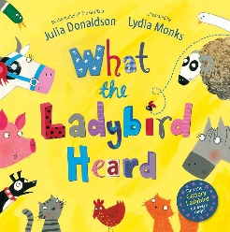 | Stuck  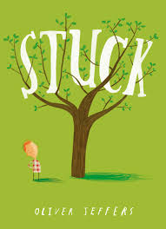 | A Cloudy Lesson (Video)  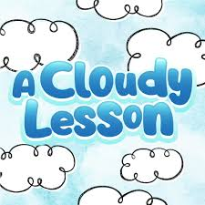 | How to Hide a Lion  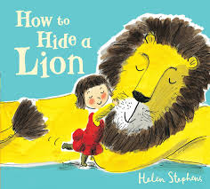 | Pudding Lane (Video)  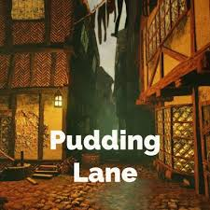 | The Koala Who Could  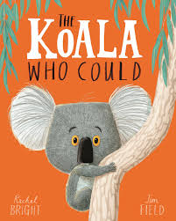
Recount | Instructions | Recount | Recount | Recount | Recount
Y1 - Capital Letters and Full Stops  The dog went to the park.  Y2 - Use the conjunction ‘but’ and ‘or’ to link basic sentences.  The dog can go to the park or he can go to the zoo.  The dog went to the park but it started to rain. | Y1 - Use question marks to demarcate sentences.  Why did the dog go to the park?  Y2 - Use the conjunction ‘so’ to link basic sentences.  It started to rain so the dog went home.  All the Ws sentence (Who? What? Where? When? Why? Would? Was? Will? What if?)  Would there ever be another opportunity like this one? | Y1 - Use exclamations to demarcate sentences.  The lost dog is at the park!  Y2 - Use expanded noun phrases for description.  The dog found a little, brown mouse. | Y1 - Use the conjunction ‘and’ to link words.  The dog and the cat went to the park.  Y2 - Use commas to separate items in a list.  The dog found a ball, a stick, a toy and a treat.  Use adverbs of time – ‘first’, ‘next’ and ‘finally’.  Y2 - Use sentences in different forms: statements, questions, exclamations and commands.  The dog went to the park.  Why did the dog go to the park?  Go to the park.  The lost dog is at the park! | Y1 - Use the conjunction ‘and’ to link basic sentences.  The dog went to the park and the cat went to the zoo.  Y2 - Use the progressive form of verbs in the past tense.  The dog was going to the park when he smelled a yummy hotdog.  Many questions sentence  Where was the treasure? The diamonds? The gold? The rubies? | Y1 - Use the conjunction ‘and’ to link clauses.  The dog went to the park and lost his ball.  Y2 – Consolidation  If, if, if, then sentence  If the alarm hadn’t gone off, if the bus hadn’t been late, if the road repairs had been completed, then his life would not have been destroyed.
Poetry |  |  |  | Poetry
‘On the Ning Nang Nong’ by Spike Milligan |  |  |  | ‘Cats’ by Eleanor Farjeon
Performance Poetry |  |  |  | Preposition Poem

Year 1 and 2 – Cycle 2
Autumn 1 | Autumn 2 | Spring 1 | Spring 2 | Summer 1 | Summer 2
Grandad’s Island  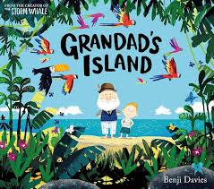 | Ivy and the Lonely Raincloud   | The Colour Monster  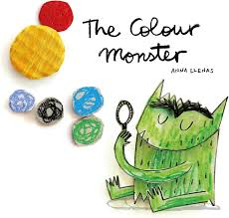 | A Squash and a Squeeze  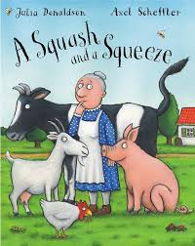 | Caterpillar Shoes (Video)  '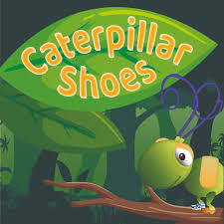 | The Deep Dark Wood  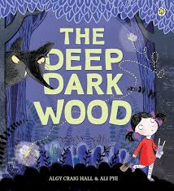
Recount | Recount | Recount | Instructions | Recount | Recount
Y1 - Capital Letters and Full Stops  The dog went to the park.  Y2 - Use the conjunction ‘or’ to link words.  The dog can choose a ball or a treat. | Y1 - Use question marks to demarcate sentences.  Why did the dog go to the park?  Y2 - Use sentences in different forms: statements, questions, exclamations and commands.  The dog went to the park.  Why did the dog go to the park?  Go to the park.  The lost dog is at the park! | Y1 - Use exclamations to demarcate sentences.  The lost dog is at the park!  Y2 - Use adjectives effectively including the suffixes -er, -est and -ly.  The park was the largest one the dog had ever been to.  The cat ran even faster than the dog.  He ran off quickly to find his friend. | Y1 - Use the conjunction ‘and’ to link words.  The dog and the cat went to the park.  Y2 - Use commas to separate items in a list.  The dog found a ball, a stick, a toy and a treat. | Y1 - Use the conjunction ‘and’ to link basic sentences.  The dog went to the park and the cat went to the zoo.  Y2 - Use the progressive form of verbs in the present tense.  The dog is going to the park. | Y1 - Use the conjunction ‘and’ to link clauses.  The dog went to the park and lost his ball.  Y2 - Consolidation
Wanted: The Perfect Pet  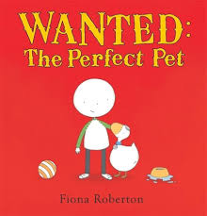 | Catch It! (Video)   | The Bridge (Video)  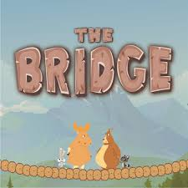 | The Barnabus Project  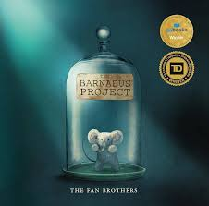 | Flat Stanley  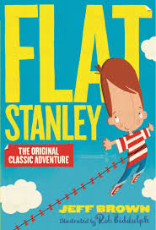 | Meerkat Mail  
Recount | Recount | Recount | Recount | Recount | Postcards
Y1 - Capital Letters and Full Stops  The dog went to the park.  Y2 - Use the conjunction ‘but’ and ‘or’ to link basic sentences.  The dog can go to the park or he can go to the zoo.  The dog went to the park but it started to rain.  B.O.B.S sentence (but, or, because, so)  She was happily playing a game, but she got upset when she lost. | Y1 - Use question marks to demarcate sentences.  Why did the dog go to the park?  Y2 - Use the conjunction ‘so’ to link basic sentences.  It started to rain so the dog went home.  All the Ws sentence (Who? What? Where? When? Why? Would? Was? Will? What if?)  Would there ever be another opportunity like this one? | Y1 - Use exclamations to demarcate sentences.  The lost dog is at the park!  Y2 - Use expanded noun phrases for description.  The dog found a little, brown mouse. | Y1 - Use the conjunction ‘and’ to link words.  The dog and the cat went to the park.  Y2 - Use commas to separate items in a list.  The dog found a ball, a stick, a toy and a treat.  Y1 - Use the conjunction ‘and’ to link words.  The dog and the cat went to the park.  Y2 - Use ‘when’, ‘if’, ‘that’ and ‘because’ to link sentences.  The dog went to the park because he was looking for his friend. | Y1 - Use the conjunction ‘and’ to link basic sentences.  The dog went to the park and the cat went to the zoo.  Y2 - Use the progressive form of verbs in the past tense.  The dog was going to the park when he smelled a yummy hotdog.  Many questions sentence  Where was the treasure? The diamonds? The gold? The rubies? | Y1 - Use the conjunction ‘and’ to link clauses.  The dog went to the park and lost his ball.  Y2 – Consolidation  If, if, if, then sentence  If the alarm hadn’t gone off, if the bus hadn’t been late, if the road repairs had been completed, then his life would not have been destroyed.
Poetry |  |  |  | Poetry
‘Sampman’ by Tao Pang Lee |  |  |  | ‘Please Do No Feed the Animals…’ by Robert Hull
Onomatopoeia Poem |  |  |  | Rhyming Poem

